1. On the sponge diagram, Identify the structure labeled "a".
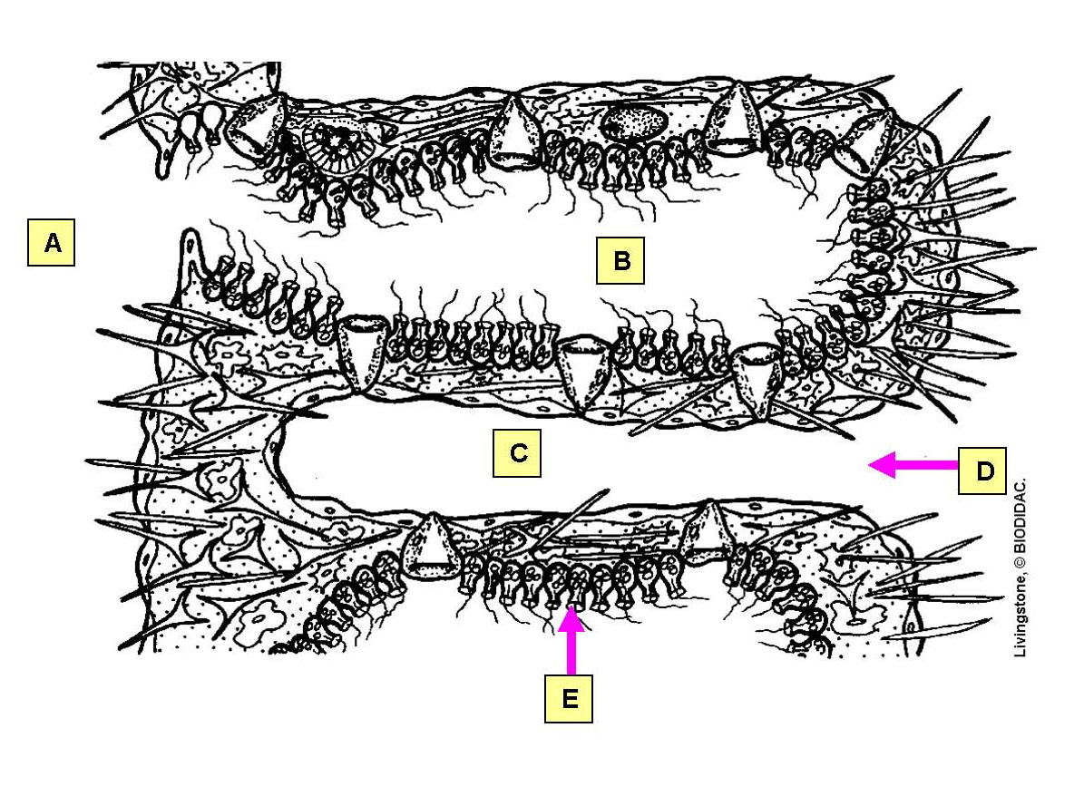

a. choanocyte
b. incurrent canal
c. osculum
d. ostium
e. radial canal
*f. spongocoel

2. On the sponge diagram, Identify the structure labeled "b".

a. choanocyte
b. incurrent canal
c. osculum
d. ostium
*e. radial canal
f. spongocoel

3. On the sponge diagram, Identify the structure labeled "c".

a. choanocyte
*b. incurrent canal
c. osculum
d. ostium
e. radial canal
f. spongocoel

4. On the sponge diagram, Identify the structure labeled "d".

a. choanocyte
b. incurrent canal
c. osculum
*d. ostium
e. radial canal
f. spongocoel

5. On the sponge diagram, Identify the structure labeled "e".

*a. choanocyte
b. incurrent canal
c. osculum
d. ostium
e. radial canal
f. spongocoel

6. On the sponge diagram, identify the structure at the tip of the pointer.
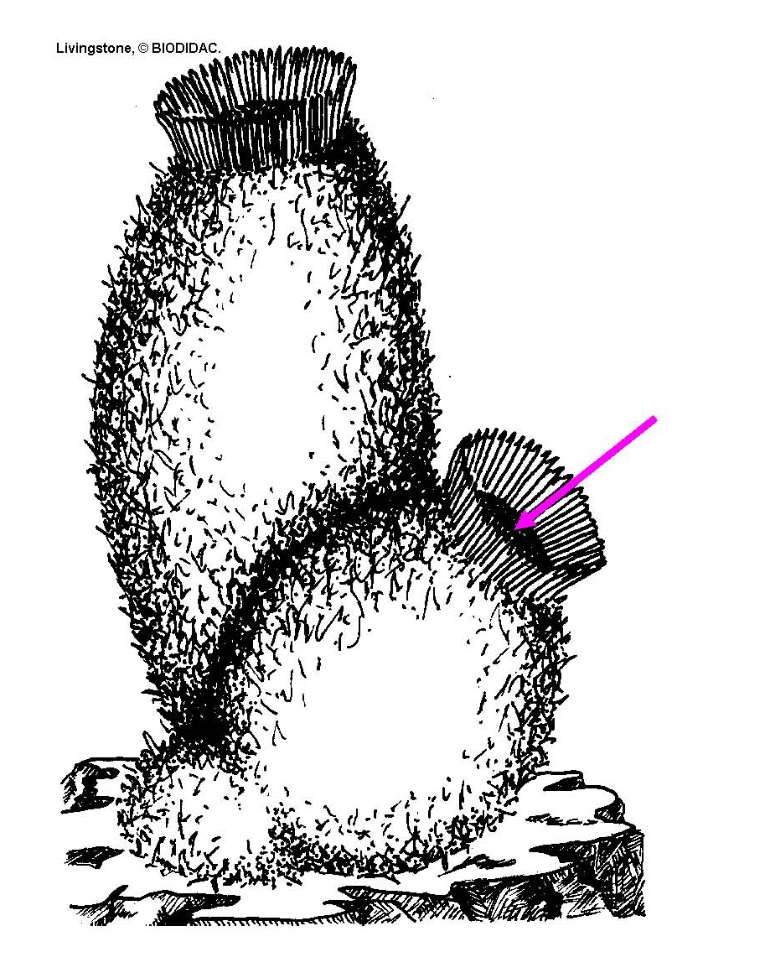

a. choanocyte
b. incurrent canal
*c. osculum
d. ostium
e. radial canal
f. spongocoel

